**PROJECT =3**

**Integrate Grafana with Linux Server for high CPU utilization and create a graph in Grafana**

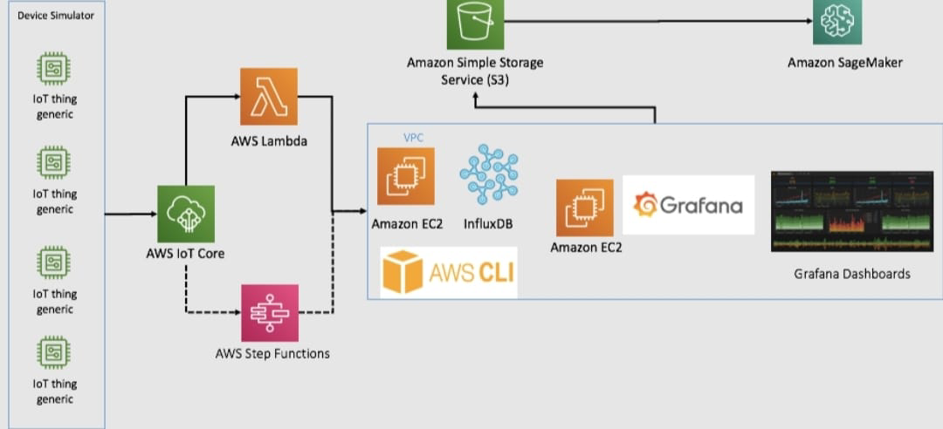

**GRAFANA**

**Grafana**isan open source analytics andinteractive visualization web application used for monitoring web application. It allow user to ingest data from a wide range of sources, query, and display it in a customizable charts ,set alerts for abnormal behaviour , and visualizes data on dashboards.



Grafana Cloud is a fully managed observability platform that provides:

* **Dashboards:** Visualize metrics, logs, and traces.
* **Integrations:** Connects with multiple data sources like Prometheus and Elasticsearch.
* **Alerting:** Set up notifications for key events.
* **Scalability:** Automatically scales with your data.
* **Security:** Features like SSO, RBAC, and data encryption.
* **Collaboration:** Share dashboards and annotations with teams
* **Support**: Access to enterprise-grade support and SLAs

**PREREQUISITES**

1. **AWS Account:**

An active AWS account.

1. **EC2 Linux Server:**

* Launch an instance running a ubuntu server.
* Configure the security groups to allow inbound and outbound traffic.

1. **Basic Knowledge about Grafana**
2. **Familiarity with CLI**
3. **Knowledge about IAM policies and roles and users.**
4. **CPU utilisation.**

**STEP 1 :**

**Sign In AWS Management Console**

* Click on the**Open Console**.



* Sign- in to your AWS account by using **Account ID,**

**Username** and **Password**.

* Once you complete sign-in , you will directed to

AWS Management Console.

**STEP 2:**

**Launch an EC2 LinuxInstance**

* Once logged in, click on **“Services”** in the top menu barUnder “Compute,” select **“EC2**” to access the EC2 Dashboard.
* In the EC2 Dashboard, click on the **“Instances”** link in the left-hand navigation pane.

* Click the **“Launch Instance”** button to begin the instance creation process
* Choose an Amazon Machine Image (AMI)

In the **“Choose an Amazon Machine Image (AMI)”** step:

* Select Ubuntu server .

* Click **“Select”** to proceed.
* Choose an Instance Type
* Configure Instance Details.
* Create a new “**key pair”**

Choose. ppk as file type.

* Configure Security Group:
* Create a **new security group**
* Configure inbound and outbound rules to control traffic to and from your instance (e.g., SSH, HTTP, HTTPS).
* Review all the configuration details of your instance.

* Make sure everything is set up correctly.
* Click **“Launch”** to start the instance creation process.
* Once the instance is launched successfully, you can view its status in the EC2 Dashboard under **“Instances.”**

**STEP 3 :**

**Editing Security Group**

* Under security group, choose the one previously created.
* Choose edit inbound rule

* Delete existing inbound security group.
* And click on add

* Add a security group with the allow all traffic.
* Custom: Choose **IPv4**.
* Then click Save.

**STEP 4:**

**Connect to the Instance**

* Connect the instance.
* Once done, click on the instance created .
* Copy **Public IP** displaying there.
* Connect out with the help of putty server .

**STEP 5:**

**Installing Grafana on Ubuntu**

**Step 5.1 - Update and upgrade**

You can do that by running the following command in your terminal:

sudo apt update -y &&sudo apt upgrade -y

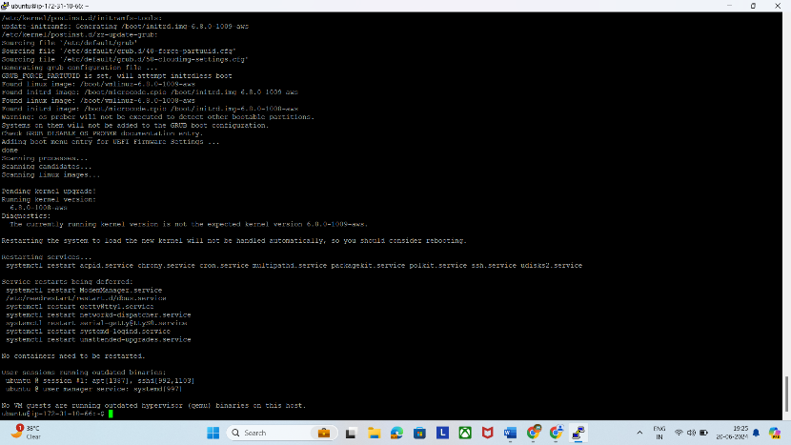

**Step 5.2 - Install the required packages**

sudo apt install -y apt-transport-https software-

properties-common wget

.**Step5.3 - Add the Grafana GPG key**

sudomkdir -p /etc/apt/keyrings/

wget -q -O - https://apt.grafana.com/gpg.key | gpg --dearmor | sudo tee /etc/apt/keyrings/grafana.gpg>

> /dev/null

The first command creates a directory where the key will be stored. The second command will download, convert, and store the key.

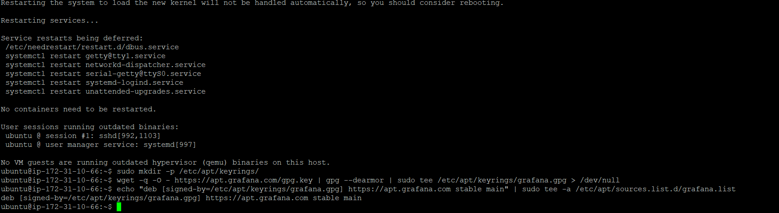

**Step 5.4 - Add Grafana APT repository**

echo "deb [signed-by=/etc/apt/keyrings/grafana.gpg]> / https://apt.grafana.com stable main" |

sudo tee -a /etc/apt/sources.list.d/grafana.list

sudo apt update

**Step 5.5 - Install Grafana**

sudo apt install grafana

**Step 5.6 - Start the Grafana service**

sudografana-server -v

sudosystemctl start grafana-server

sudo systemctl enable grafana-server

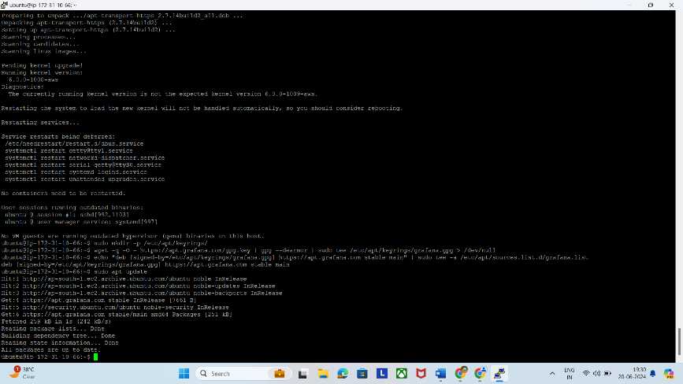

**Step 5.7 - Verify that the Grafana service is running**

sudo systemctl status grafana-server

**Step 5.8 - Open the port in the firewall**

sudoufw enable

sudoufw allow ssh

sudo ufw allow 3000/tcp

**Step 5.9 - Access the Grafana web interface**

To access the Grafana web interface, open a web browser and enter the IP address of your server

followed by port 3000. The URL format should be [http://your_server_IP:3000](http://your_server_ip:3000)

Once loaded, you should see the Grafana login page. The default credentials are:

**Username:**admin (your username)

**Password:**admin (your password)

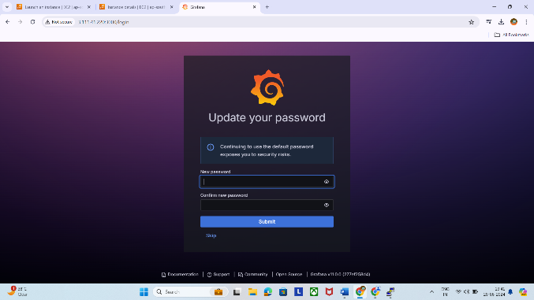

You'll be prompted to create a new password. Input a secure password, confirm it, and clickthe "**Submit "** button.

the "Submit

Once done, you'll have access to Grafana's dashboard.

* **Grafana configuration process:**

**STEP 6:**

**Create an IAM Policy**

* Go to **Services** and Select IAM.

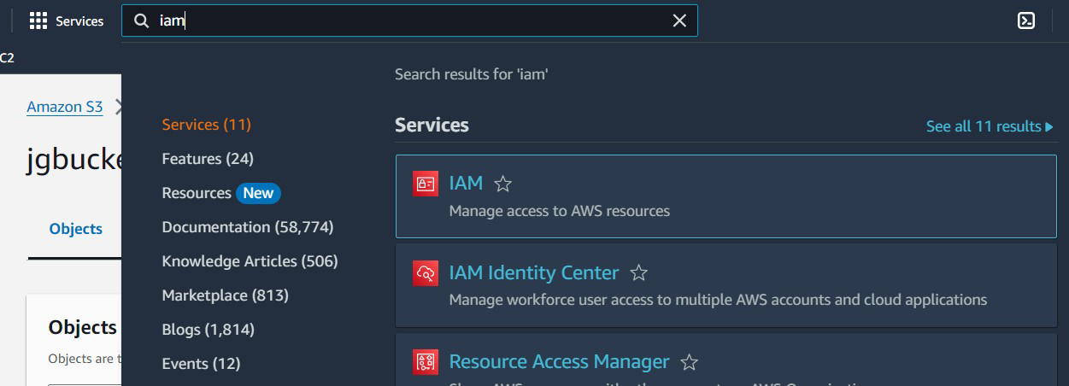

* Click on **Policies** in the left navigation bar and click on the **Create Policy** button.

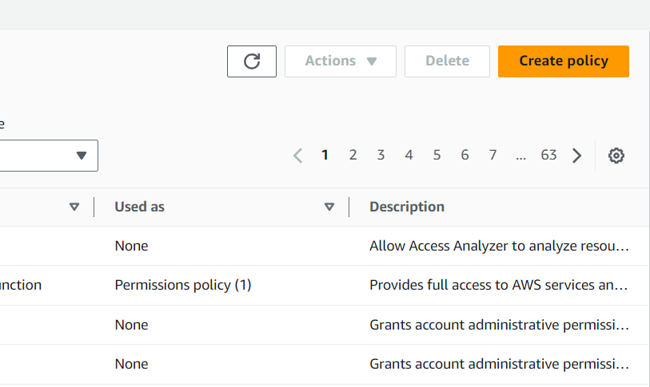

* Choose the **JSON** tab.

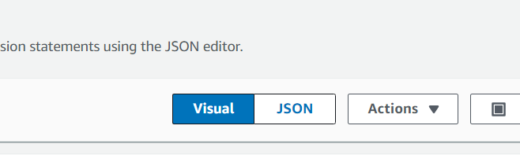

* Remove the existing one and add the given

Statement in the editor.

* Policy JSON:

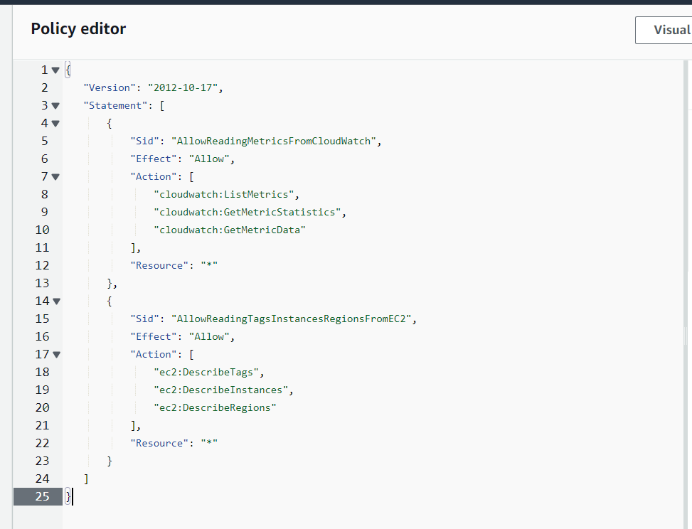

* Leave everything as default, click **Next**.
* On Policy Page:Enter Policy Name.
* Click **Create policy.**

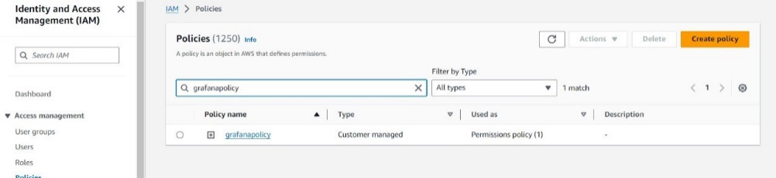

* An IAM Policy is created.

**STEP 7:**

**Create an IAM Role**

* Click on **Roles** from menu displaying on left side.
* Click on **Create role** button.
* Search **EC2** from services list.
* From **Trusted Entity Type :**Select **AWS Service.**
* From **Use case:** Select**EC2.**

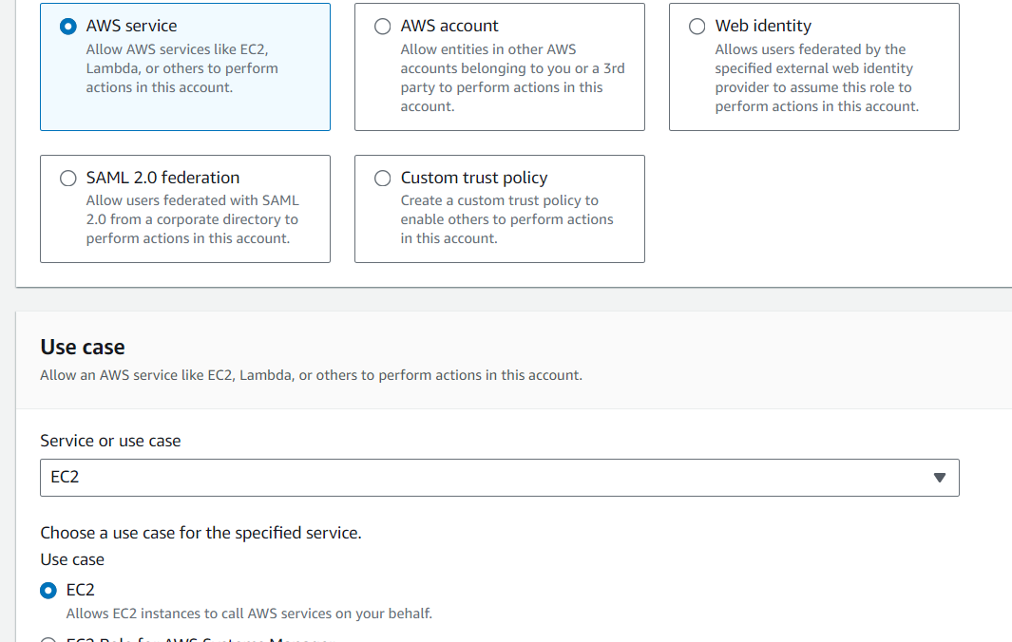

* Select the created policy and click on **Next.**
* **Role Name:** Enter**grafanarole.**
* Click on the **Create Role.**
* IAM Role is created successfully.

**STEP 8:**

**Modifying EC2 Instance**

* Go to **Services** and Select EC2.
* Select **Instances**.
* Select your created instance.
* Choose **Actions** and select **Security.**
* Under security, select **ModifyIAM role**.
* Choose the role crated by you in previous step.
* Click and save changes.

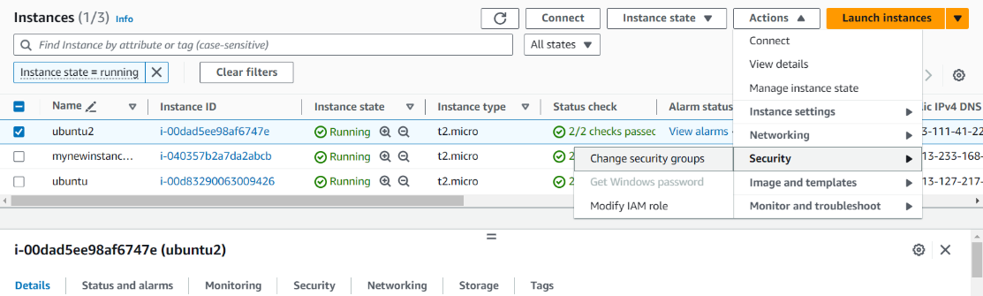

**STEP 9 :**

**Create a new user**

* Go to the **Services** and select **IAM**.
* From the left menu select **Users.**
* Click on **Create a new user**.
* Give name to the user and and add it to an existing group.
* Click on create a new user.
* Give access to the policy created in previous step.
* Click on the user created and select **Access keys**.
* From there copy **Access key** and **Secret access key** in a text file for further use.

**Step 10:**

**GrafanaSetup**

* Go the Grafana homepage, and select Connection.
* Then **Add new connections.**
* Go and select **CloudWatch**.
* Then choose to **add new data source**.
* Click on **Settings**.
* In given CloudWatch details:
* **Auth provider**: Select **Access and Secretkey**.
* **Access key ID:** Copy and paste access key.
* **Secret Access key:** Copy and paste**.**
* **Default region :**select **ap-southeast-1.**
* Click **Save and Test**.

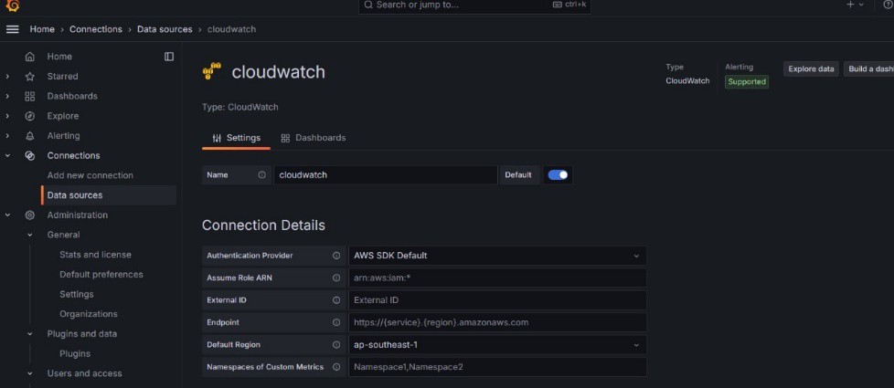

**STEP 11:**

**Importing CloudWatch Dashboard**

* In dashboard it shows five of most popular AWS services.
* Choose **Amazon Elastic Cloud (EC2)**.

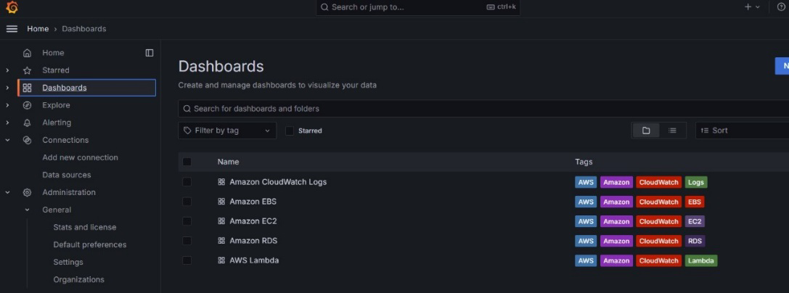

* Click **Import** the graph for EC2.
* Visit the dashboard you imported in the previous step and take a look at he metrices and logs being visualized.

